**JOB PORTAL**

CA2 open source technology

K Sai Prabhakar

11603432

RKE009A08

Submitted to Ms Shivali chopra

Git hub link: https://github.com/PrabhakarKotipalli/CA-2

**Description:**

Job portal website is designed by PHP and mysql database.

In this file, the screen shots of the website will be shared and output of the project will be in the screen shots There is no need for any user and password.

The job portal only you can use to search jobs by the bases of your skills and languages like c, python, java etc.

In the backend there will be only a table with the data of job suitable skills.

All the files and data base is shared in the folder.

**Screenshots with outputs:**

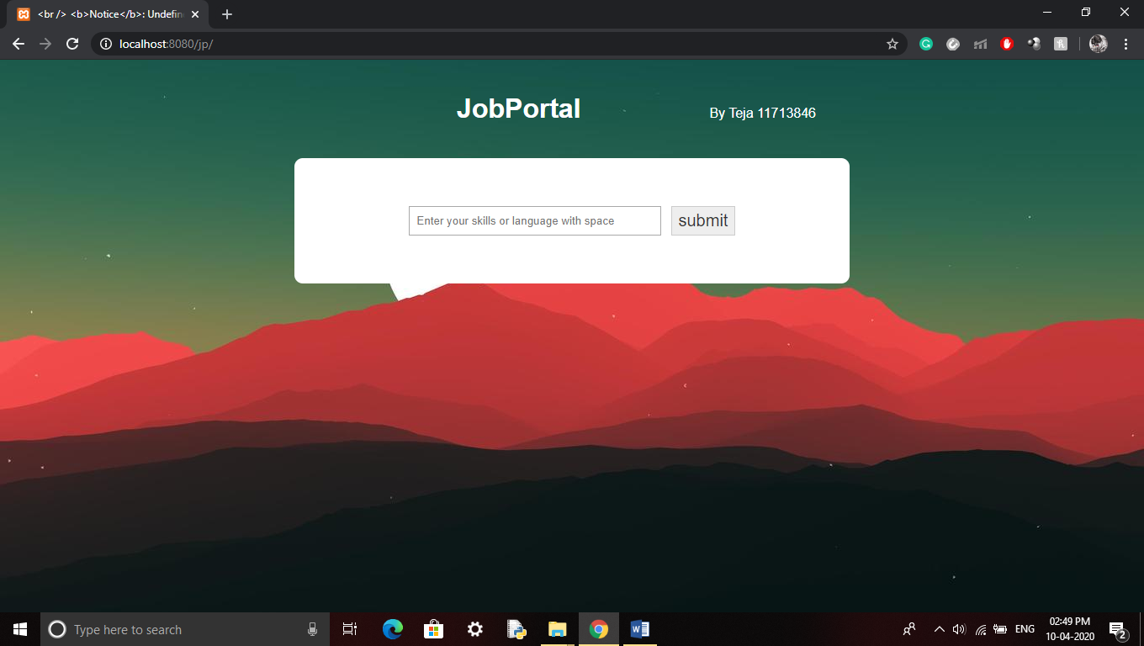

First page with a search engine:

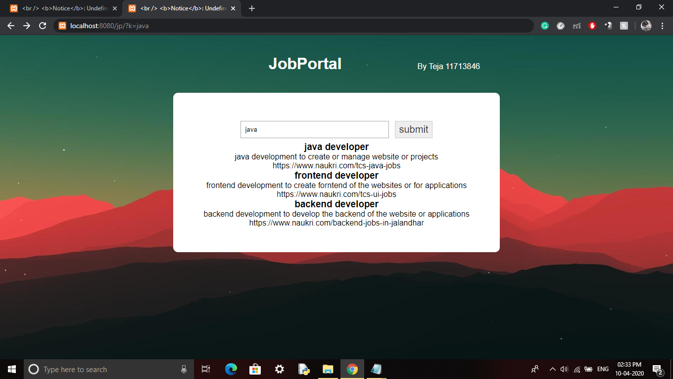

This screenshot is having an output of skill = java in the search engine

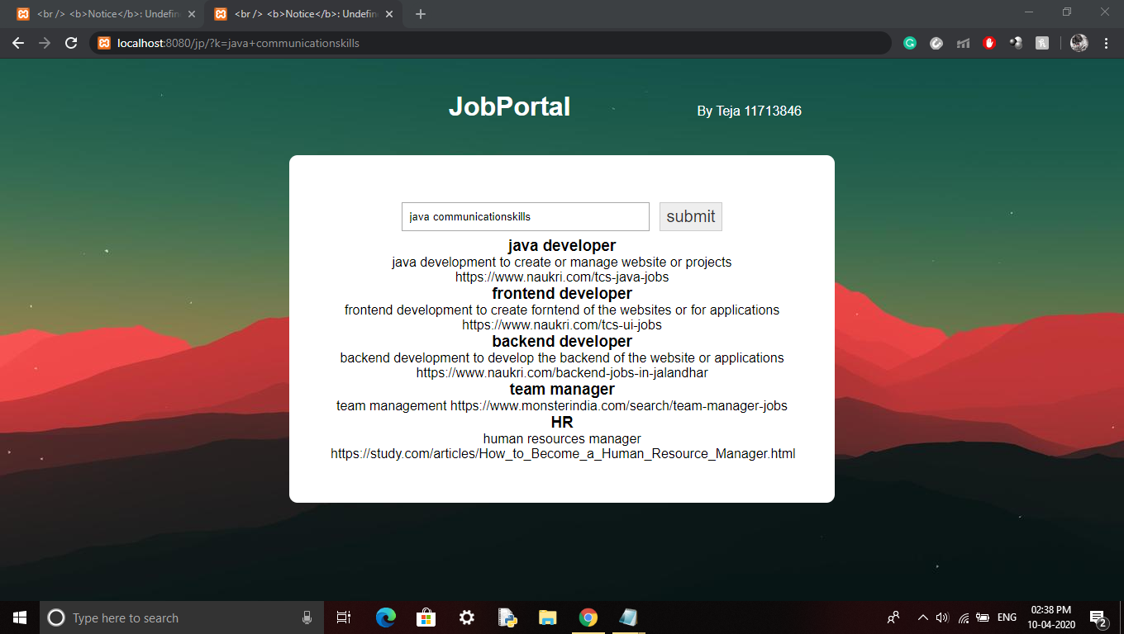

This screenshot is having an output of skill= java communication skill in the search engine.

The search engine searches the user input in the table column of keyword, which is there in the sql data base, the matching keyword row will be display in the output box.